Project Design Phase - I Solution Architecture

|  |  |
| --- | --- |
| Date | 3 October 2022 |
| Team ID | PNT2022TMID17383 |
| Project Name | Project – Smart Farmer-IoT Enabled Smart Farming Application |
| Maximum Marks | 4 Marks |

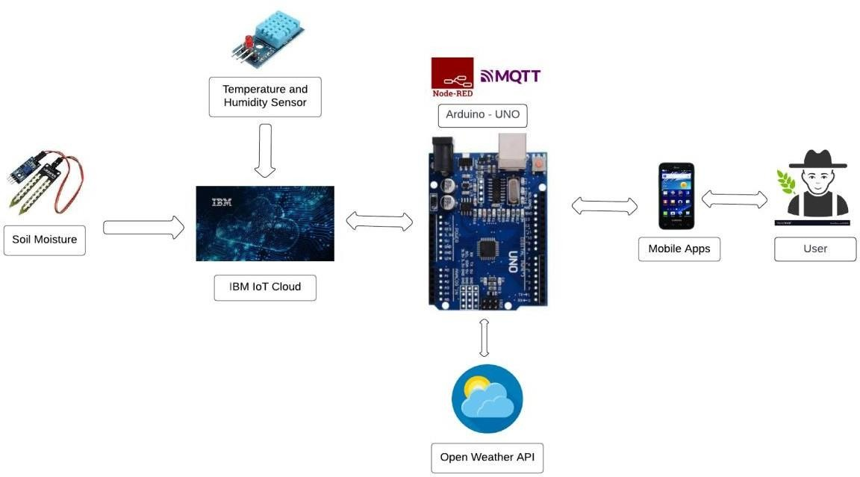

The proposed solution will assist farmers by getting live data (Temperature, humidity, soil moisture) from the farmland to take necessary steps to enable them to do smart farming by also increasing their crop yields and saving resources (water, fertilizers).

The architecture of proposed system consists of various blocks:

# SENSORS

The soil moisture sensor senses the moisture level in the soil. The humidity and temperature sensor gives the humidity and temperature values of the atmosphere which determine whether the crop is suitable for growth. The soil moisture sensor, humidity and temperature sensor continuously monitors the soil and environmental conditions, sends the live data to mobile.

# ARDUINO UNO

Arduino Uno is the heart of the system. The facts gathered with the aid of the sensors are sent to the Arduino UNO. The gathered information may be displayed in a Arduino IDE.

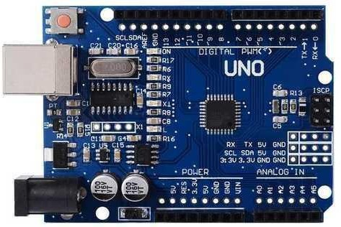

# SOIL MOISTURE SENSOR

A soil moisture sensor empowers agriculturalists to estimate the water levels without the need to be physically present in the field.

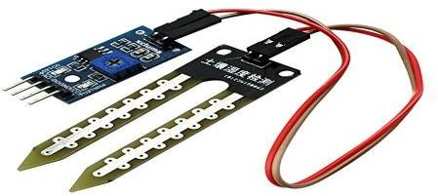

# HUMIDITY SENSOR

Humidity sensors are electronic devices that measure and report the moisture and air temperature of the surrounding environment.

1. The different soil parameters (temperature, humidity, Soil Moisture) are sensedusing different sensors, and the obtained value is stored in the IBM cloud.
2. Arduino UNO is used as a processing unit that processes the data obtained from sensors and weather data from weather API.
3. Node-red is used as a programming tool to wire the hardware, software, and APIs. The MQTT protocol is followed for communication.
4. All the collected data are provided to the user through a mobile application that wasdeveloped using the MIT app inventor. The user could make a decision through an app, whether to water the crop or not depending upon the sensor values. By using the app they can remotely operate the motor switch.